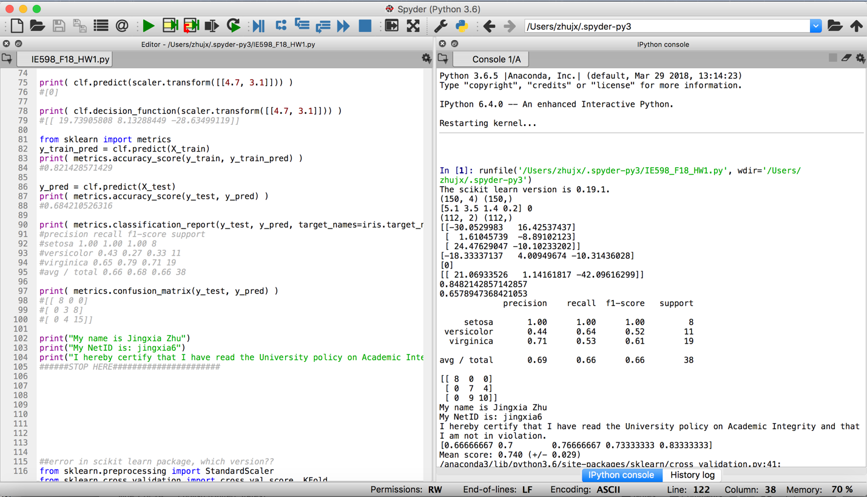Jingxia Zhu(jingxia6)

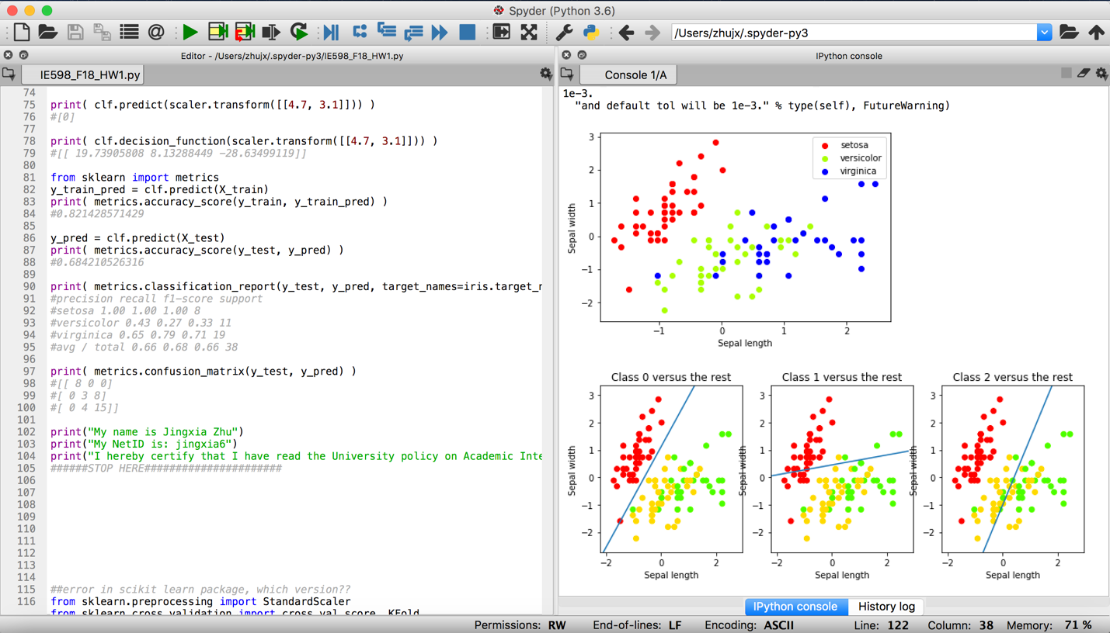9/2/2018

GitHub link:

<https://github.com/jzhuuhzj/IE598_F18_HW1.git>